**Record of Ex. No: 3 –Fundamentals of Projection (Orthographic projection of points, Straight lines inclined to one plane and free hand sketching)**

**Date of experiment:** 29.04.2021 **Date of submission:** 29**.**04.2021

**Name:** Kunal Keshan S **Department:** ECE – A **Roll No:** RA2011004010051

**Aim:**

To learn and understand the basics of orthographic projection of simple objects such as a point, straight line parallel and inclined to one plane and free hand sketching.

**Software used:** AutoCAD.

**Procedure:**

|  |  |
| --- | --- |
| Commands Used | Purpose of Command |
| UNITS | To set the units of the drawings. |
| LIMITS | To set the limits of the drawing area. |
| ZOOM | To adjust the view of the drawing area. |
| LINE | Used to draw a line. |
| POINT | Used to place a point on the drawing area. |
| TEXT | Used to add text in the drawing area. |
| TEXTEDIT | Used to edit any existing text. |
| DIMLINEAR | Used to add linear dimensions. |
| DIMALIGNED | Used to add aligned dimensions(i.e parallel to a line or point that is not perpendicular) |
| DIMANGLE | Used to add dimensions between any two lines or arcs. |
| DDPTYPE | Used to set the type of point and its size. |

**Steps:**

1. Adjust the right units and limits of the drawing area using UNITS AND LIMITS.
2. Draw a line XY of appropriate length and label above the line as V.P. and below the line as H.P.
3. Now depending on the question, the V.P. usually represents the front view and the H.P. usually represents the top view of a point, line or an object in the case of a FIRST ANGLE PROJECTION.
4. After marking the points and the lines, label the points and give them dimensions using TEXT and DIMLINEAR, DIMALIGNED and DIMANGLE.

**Question 1:**  Draw the projections of the following points on the same reference line, keeping the projectors 25mm apart from each other.

1. A point 10mm above HP and 10mm in front of VP.
2. A point 10mm above HP and 10mm behind VP.
3. A point 10mm below HP and 10mm in front of VP.
4. A point 10mm below HP and 10mm behind VP.

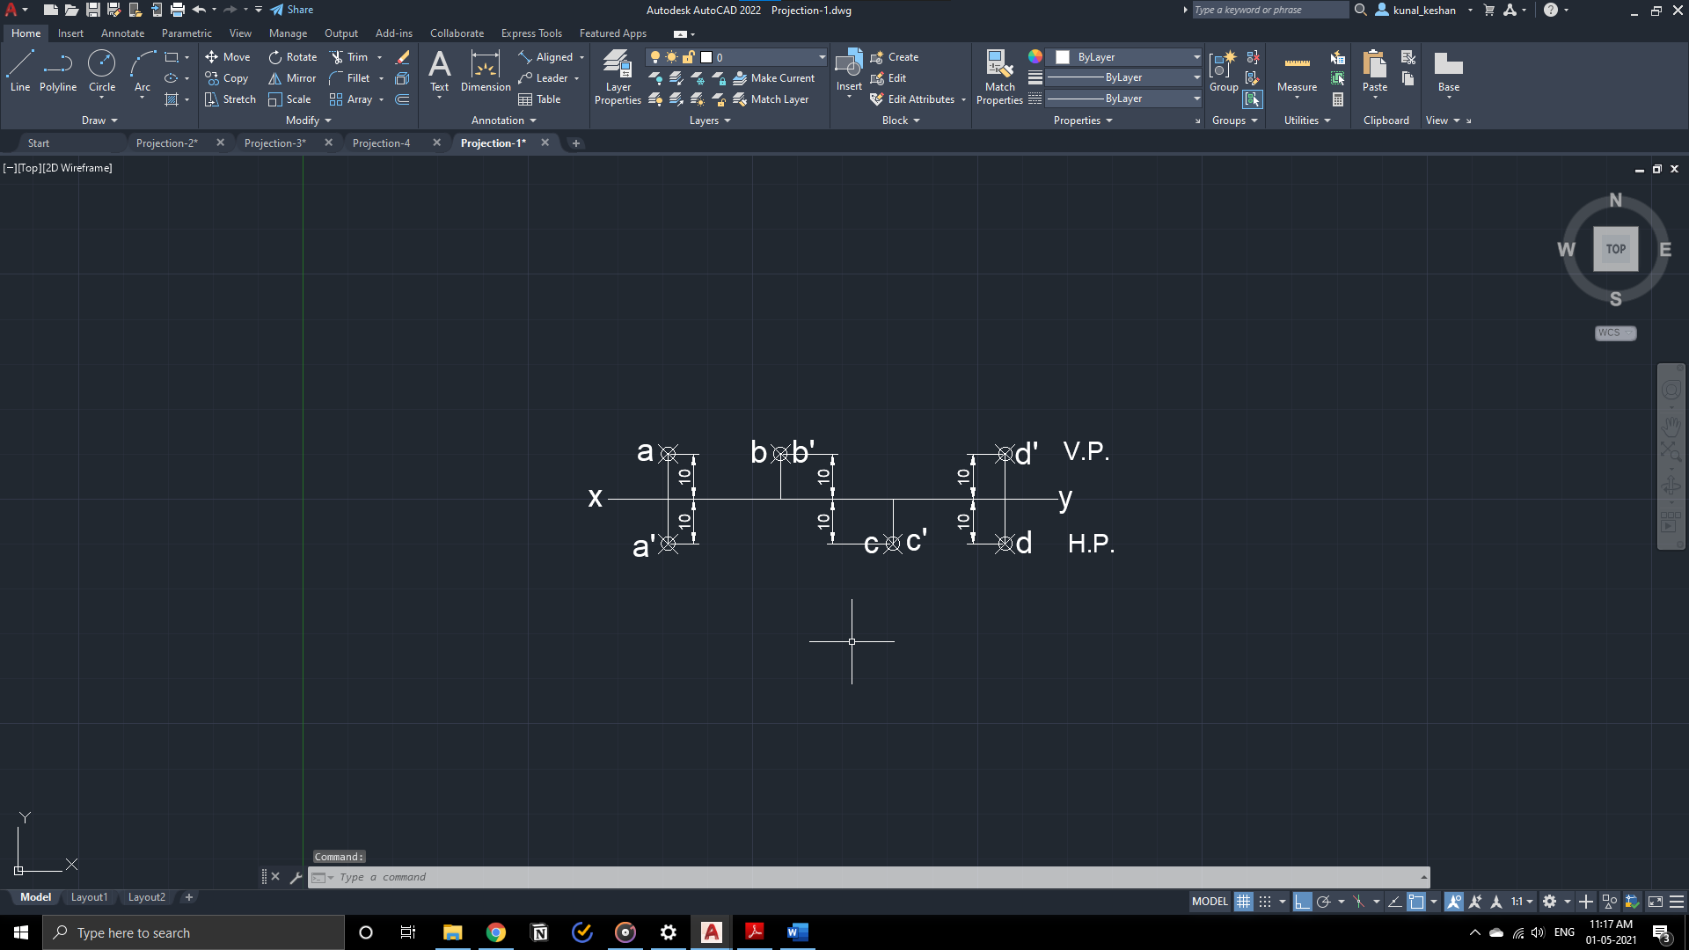

**Question 2:** Draw the orthographic multi-view projections of the following points. Choose the appropriate scale if required.

1. A toy boat (idealized as a point R) is floating inside a square well 3m below HP (floor) and 1m behind VP (wall).
2. A box (idealized as a point S) is kept in the steps, which is 5m below HP (floor) and 4m in front of VP (wall) from the observer.

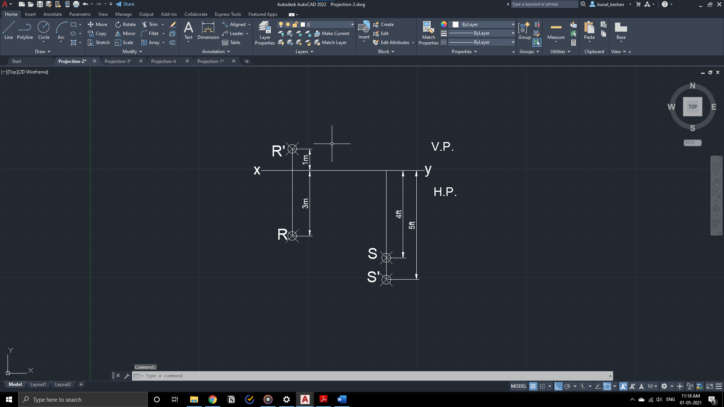

**Questions 3:** Draw the multi-view projection of straight lines inclined to only one place.

1. The length of top view of a line, AB parallel to the VP and inclined at 45° to the HP is 50mm. One end of the line A, is 12mm above the HP and 25mm in front of the VP. Draw the projections of the line and determine its true length.
2. The front view of a 7.5m long post (idealized as a line AB) lying on the ground measures 5.5m. One of its end A is in the wall. Draw the projections of the line and determine its inclination to the wall (VP).

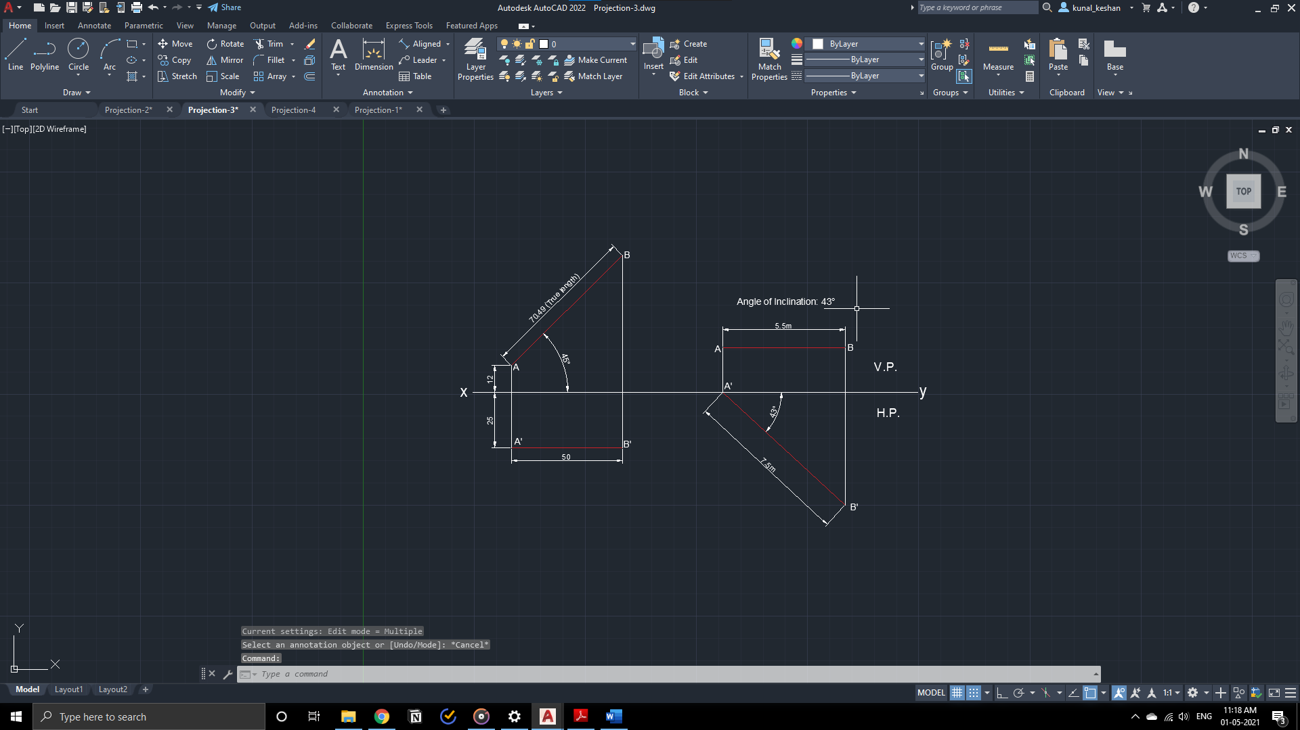

**Questions 4:** Draw a free-hand(manual/CAD) CREATIVE conceptual drawing of a PROPOSED (modify the existing product like pen, sharpener, micro tip pencil, stapler, car, airplane etc) also new, presently non-existing features must be added to the existing product. Label the parts and list out the special features of the product.

**Result:**

The orthographic projection of a point, straight line inclined to one plane and free hand diagram were drawn with the required dimensions.